**Southern University Bangladesh**

Department of Computer Science and Engineering

Course Code & Title: System Analysis and Design

Semester: Fall 2023

**Lab Report**

**Project Title: WasteAlert : Citizen-Centric Waste Management Complaint System**

**Submitted by:**

|  |  |
| --- | --- |
| Student 1:  ID: 666-58-05 | Name: Shakil Ahamed Shuvo |
| Student 2:  ID:666-58-01 | Name: Abdullah Al Durud |

**Submitted to:** Engr. Mohammed Arif Hasan Chowdhury

Assistant Professor

Dept. of Computer Science

Southern University Bangladesh

**WasteAlert : Citizen-Centric Waste Management Complaint System**

**Description:**

In the modern urban landscape, effective waste management is pivotal for maintaining a clean, healthy, and sustainable environment. To harness the power of citizen engagement and revolutionize waste management practices, we present the "WasteAlert" project—a cutting-edge online platform designed to empower residents in reporting and resolving waste-related issues within their city. WasteAlert seeks to bridge the gap between citizens and local authorities, fostering collaboration for a cleaner and more livable urban environment.

WasteAlert is a groundbreaking initiative that harnesses the power of technology to transform waste management within our city. This innovative online platform empowers every citizen to become an active contributor to a cleaner and more sustainable urban environment. With WasteAlert, residents have a simple yet effective tool at their fingertips to report waste-related issues, such as overflowing bins, littering, and missed collections.

The platform's user-friendly web and mobile interface make reporting complaints a seamless experience. Through geo-tagging and photo attachments, citizens can provide accurate information, enabling waste management teams to swiftly locate and address the reported issues. Real-time notifications keep citizens informed about the progress and resolution of their complaints, enhancing transparency and communication.

**WasteAlert** goes beyond problem-solving; it's a platform that nurtures a sense of community ownership and responsibility. Citizens' contributions are recognized and celebrated, creating a culture of active involvement. The platform also serves as an educational hub, offering citizens resources and guidelines for responsible waste disposal, further reinforcing the city's commitment to sustainability.

**Goal of project:**

The primary goal of the **WasteAlert** project is to establish a dynamic and citizen-centric waste management complaint system that empowers residents to actively participate in maintaining a cleaner, healthier, and more sustainable urban environment. By providing a seamless platform for reporting waste-related issues, the project aims to achieve the following objectives:

1. **Empower Citizen Engagement:** By making it easy to raise complaints about garbage, you may encourage individuals to take an active role in waste management and develop a feeling of ownership and responsibility for their surroundings.
2. **Enhance Efficiency:** Simplify the waste management process by speedily detecting, identifying, and resolving waste-related problems that locals have reported. This effectiveness results in quicker response times and better problem solving.
3. **Foster Transparency:** Create open lines of contact between residents and local government, making sure that people are informed about the status and outcome of their reported issues.
4. **Enhance urban hygiene**: by swiftly resolving waste-related issues that may otherwise result in unhygienic situations, health risks, and environmental damage. This will help to make cities cleaner and healthier.
5. **Optimize Resource Allocation:** Utilize data analytics to gain insights into complaint patterns and waste management trends. This information guides informed decision-making, helping allocate resources effectively and implement targeted waste management strategies.
6. **Promote Sustainability:** Educate citizens about responsible waste disposal practices through the platform's educational resources and guidelines, fostering a culture of sustainable waste management.

**Methodology :**

We use the Waterfall methodology for your **"WasteAlert: Citizen-Centric Waste Management Complaint System" project**. The Waterfall methodology is a linear and sequential approach to project management. Here's how we could apply the Waterfall methodology to your project:

**Waterfall Methodology:**

**1. Requirements Gathering:**

Gather detailed requirements for the WasteAlert platform. Work closely with stakeholders, waste management experts, and potential users to understand their needs and expectations.

**2. System Design:**

Create a comprehensive design for the platform based on the gathered requirements. This includes designing the user interface, database structure, and overall system architecture.

**3. Implementation:**

Develop the WasteAlert platform according to the design specifications. Build the website and mobile app, integrate features such as complaint submission, geo-tagging, and real-time notifications.

**4. Testing:**

Conduct thorough testing of the developed system to ensure that it functions as intended and meets the specified requirements. Perform various types of testing, including functional, usability, and performance testing.

**5. Deployment:**

Once testing is complete and the platform is ready, deploy it for real-world use. This involves making the system accessible to users and integrating it with the necessary infrastructure.

**6. User Training:**

Provide training to users on how to use the WasteAlert platform effectively. This ensures that citizens and waste management teams can use the system with confidence.

**7. Maintenance and Support:**

After deployment, provide ongoing maintenance and support to address any issues that arise, apply updates, and make necessary improvements.

**Advantages of Using Waterfall:**

**Clear Structure:** The Waterfall methodology provides a structured and organized approach to project management, making it easier to plan and execute.

**Clear Documentation:** Each phase's outputs are well-documented, allowing for easy tracking of progress and maintaining a record of decisions.

**Early Design:** Detailed design is completed before development starts, minimizing the risk of misunderstandings and changes during the development phase.

**Predictable Timeline**: With a defined sequence of phases, the project's timeline can be estimated more accurately from the start.

**Minimal User Involvement:** Waterfall is suitable when detailed requirements are well-defined upfront and there is less need for continuous user involvement.

Applying the Waterfall methodology to the WasteAlert project will lead to a well-defined and thoroughly tested waste management system. This approach is suitable when requirements are stable and clearly defined from the outset.

**Benefits:**

The "WasteAlert: Citizen-Centric Waste Management Complaint System" project offers a range of benefits that positively impact both the community and waste management practices. Here are some key advantages of implementing this project:

1. **Enhanced Civic Engagement:** The project encourages citizens to actively participate in waste management by reporting issues, fostering a sense of responsibility and ownership for their environment.
2. **Improved Cleanliness**: Prompt reporting and resolution of waste-related problems lead to a cleaner and more attractive urban landscape, contributing to better public health and quality of life.
3. **Efficient Waste Management:** The platform's streamlined process ensures that waste-related complaints are quickly addressed, reducing potential health hazards and unsightly conditions.
4. **Transparency and Accountability:** Real-time notifications and status updates promote transparency in waste management efforts, building trust between citizens and local authorities.
5. **Data-Driven Insights:** The platform's analytics provide valuable data on complaint trends and waste management patterns, enabling evidence-based decision-making for resource allocation and improvement strategies.
6. **Community Cohesion:** The project fosters a shared sense of responsibility among citizens, promoting a more tightly knit and socially responsible community.
7. **Effective Resource Allocation:** By identifying complaint trends, waste management teams can allocate resources efficiently, focusing on areas with higher reported issues.
8. **Sustainable Practices:** Educational resources within the platform encourage citizens to adopt responsible waste disposal practices, contributing to a more sustainable urban environment.
9. **Citizen Empowerment:** The platform empowers citizens to be active contributors to waste management solutions, reinforcing the notion that individual actions collectively shape the city's environment.
10. **Positive Public Image:** Implementing an innovative waste management solution demonstrates the city's commitment to sustainability, improving its reputation and attractiveness to residents and visitors.

**Risk of project:**

Implementing the "WasteAlert: Citizen-Centric Waste Management Complaint System" project comes with various potential risks and challenges. Identifying these risks is crucial for ensuring the successful execution of the project. Here are some key risks to consider:

1. **Technology Risks:**

* **Technical Challenges**: Complications in development, integration concerns, or unexpected technological restrictions might result in delays and higher costs.
* **Compatibility Issues:** Compatibility problems with different devices, browsers, or operating systems could affect user experience.

1. **Data Security and Privacy:**

* **Data Breaches:** Insufficient security measures could result in data breaches, compromising user information and damaging trust.
* **Privacy Concerns:** User data collection for complaints must follow privacy standards and acquire user authorization.

1. **User Adoption and Engagement:**

* **Low Participation:** If citizens don't actively participate, the system's effectiveness may be limited.
* **User Experience:** A bad user interface or a complex user experience may discourage participation.

1. **Resource Constraints:**

* **Budget Overruns:** Poor budget management or unplanned costs may cause the budget that was given to be exceeded.
* **Resource Availability:** Lack of skilled personnel or other required resources might slow down progress.

1. **Communication and Collaboration:**

* **Miscommunication:** Lack of clear communication between stakeholders, developers, and waste management teams could lead to misunderstandings.

**Cost-analysis:**

**Project Time frame:**

**Feasibility analysis:**

**Technical Feasibility:**

**Expertise:** Ensure the availability of skilled developers proficient in web and mobile app development, as well as GIS technologies for mapping functionalities.

**Infrastructure:** Assess the availability of reliable hosting services and database solutions to support the platform's expected user load.

**Integration:** Determine the feasibility of integrating with existing databases and municipal systems used by waste management teams.

**Economical Feasibility:**

**Budget:** Evaluate the project budget in terms of development costs, maintenance, and operational expenses. Compare this against the expected ROI.

**ROI Analysis:** Estimate the benefits such as reduced operational costs, improved citizen satisfaction, and optimized waste management processes. Calculate the potential ROI to justify the investment.

**Organizational Feasibility:**

**User Adoption**: Conduct surveys or pilot studies to gauge citizen and waste management team interest and willingness to adopt the new system.

**Training:** Assess the training requirements for users and waste management personnel. Ensure the system is intuitive and requires minimal training.

**Support:** Ensure there is a plan for ongoing support, bug fixes, and updates post-launch to maintain operational efficiency.

**Training and Skill Enhancement:** Plan training sessions or workshops to enhance the skills of existing employees if there are gaps in expertise.

We Using interview and survey techniques for the "WasteAlert: Citizen-Centric Waste Management Complaint System" project’s Requirement gathering. That provide valuable insights from different perspectives. Here's why these techniques are beneficial:

**Interview:**

interviews allow for detailed, one-on-one discussions with key stakeholders, such as citizens, waste management teams, and officials. This facilitates a deeper understanding of their needs, expectations. Interviews provide an opportunity to seek clarifications and gather additional information in real-time. This helps in avoiding misunderstandings and ensures a more accurate representation of requirements.

**Survey technique:**

Surveys enable the collection of feedback from a larger audience, including citizens who may be geographically dispersed. This help to know about what citizen want.

Surveys is also cost-effective, especially when reaching a large audience. We use Online survey tools and platforms make it convenient to distribute surveys and collect responses efficiently.

Using both techniques ensures a more comprehensive understanding. While interviews dive deep into specific issues and user experiences, surveys provide a broader perspective and gather opinions from a larger sample. Those help us for the requirement analysis for this project.

**Requirement analysis:**

**1. Functional Requirements:**

User Registration and Authentication:

Citizens, waste management teams, city officials, and system administrators should have secure authentication mechanisms.

Complaint Submission:

Citizens should be able to submit complaints, providing details such as type of waste issue, description, and optional image attachments.

Complaint Management:

Waste management teams should be able to view, update, and resolve complaints. The system should track the status of each complaint.

Analytics and Reporting:

City officials should have access to analytics and reporting features, including graphical representations of complaint trends, response times, and geographical distribution.

User Account Management:

System administrators should be able to manage user accounts, including creation, modification, and deactivation.

**Non-Functional Requirements:**

Usability:

The system should have an intuitive and user-friendly interface for citizens, waste management teams, and city officials.

Performance:

The system should be responsive and capable of handling a large number of concurrent users, ensuring quick complaint submissions and updates.

Scalability:

The system should be scalable to accommodate future growth in the number of users and complaints.

Security:

Robust security measures should be implemented to protect user data, ensure privacy, and prevent unauthorized access.

Reliability:

The system should be reliable, with minimal downtime, ensuring continuous availability for complaint submissions and management.

Compatibility:

The system should be compatible with various devices and browsers to accommodate users with different preferences.

**Use Case Diagram:**

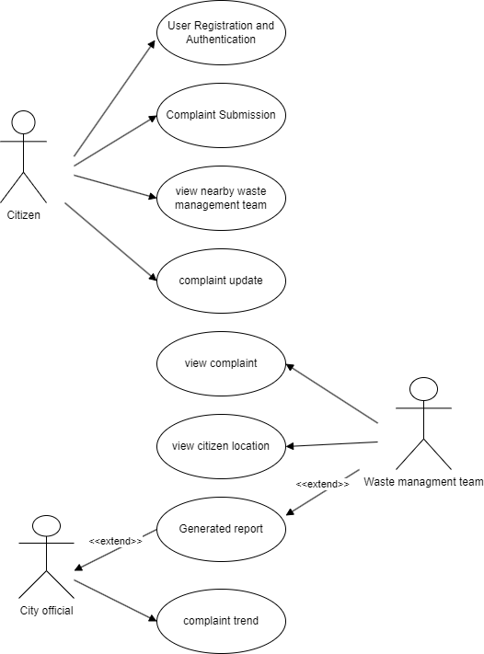

**Context diagram/Level 0 DFD:**

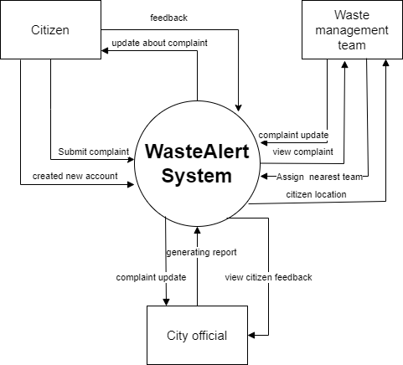

Level 1 DFD:

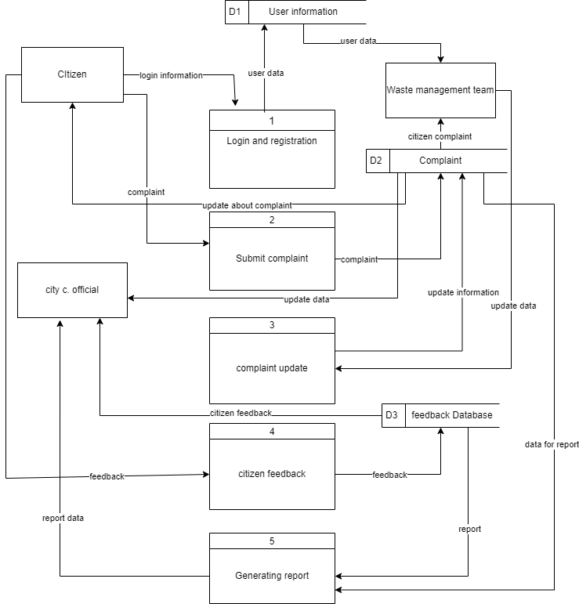

Level 2 DFD:

­­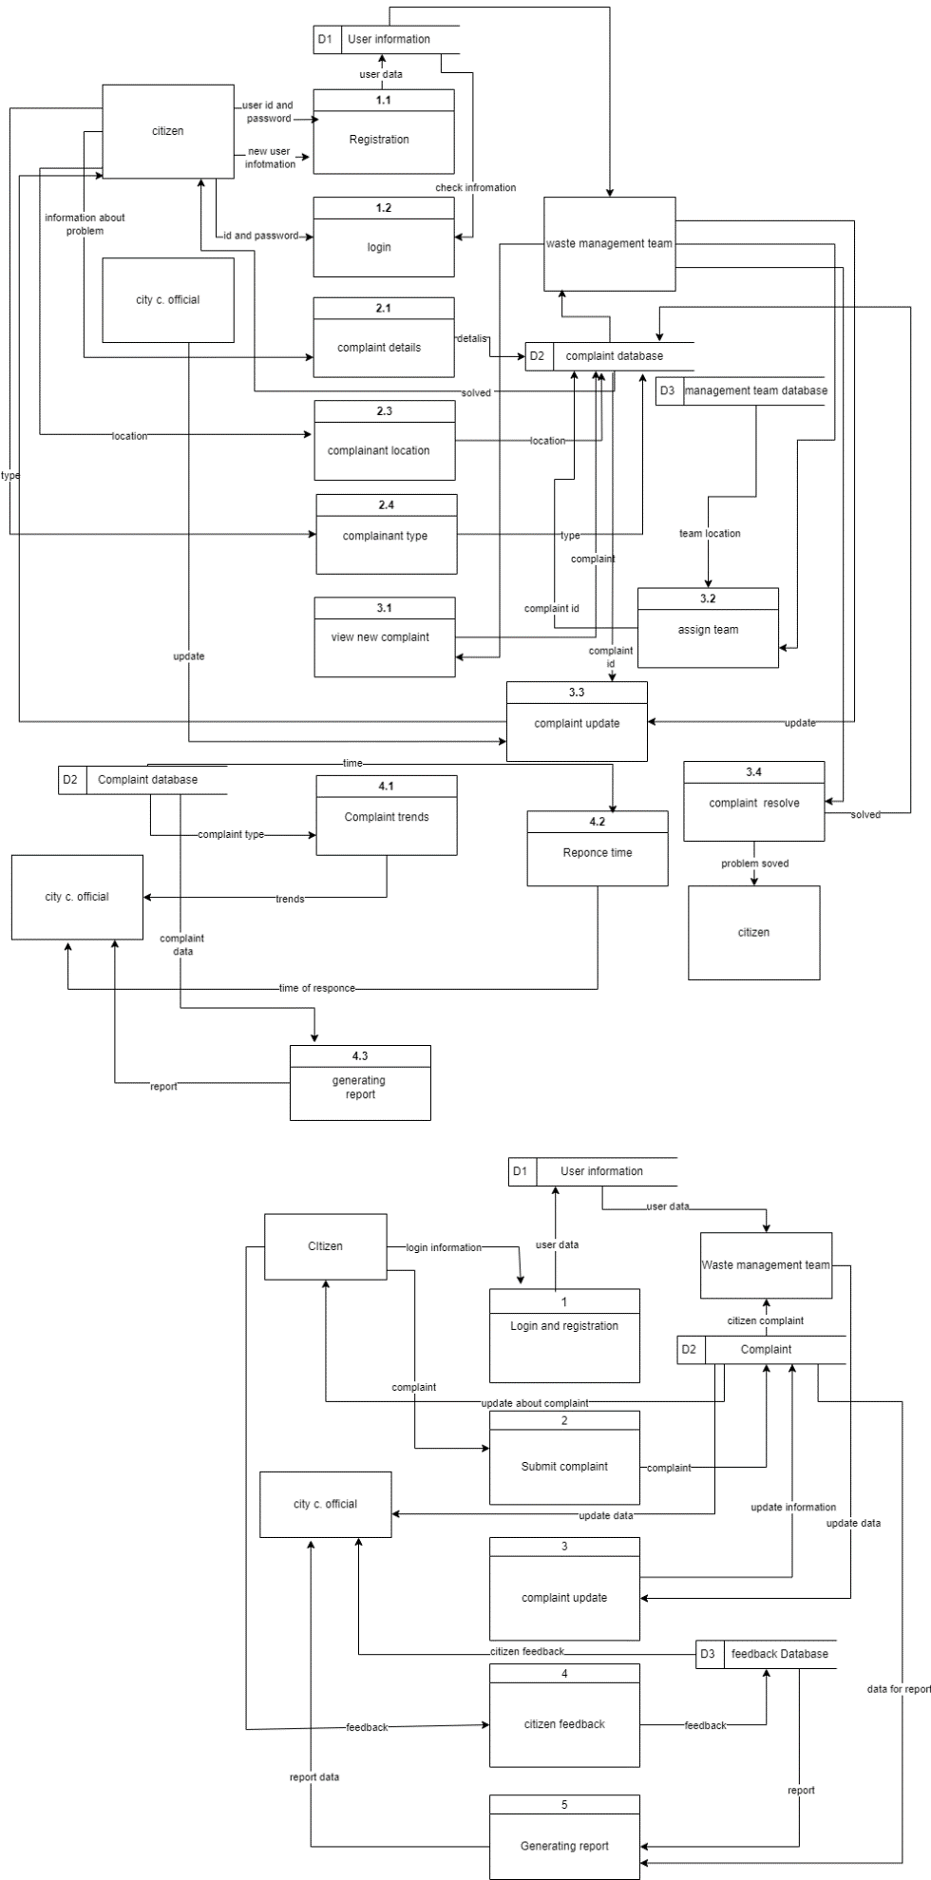

Class diagram:

Sequence diagram:

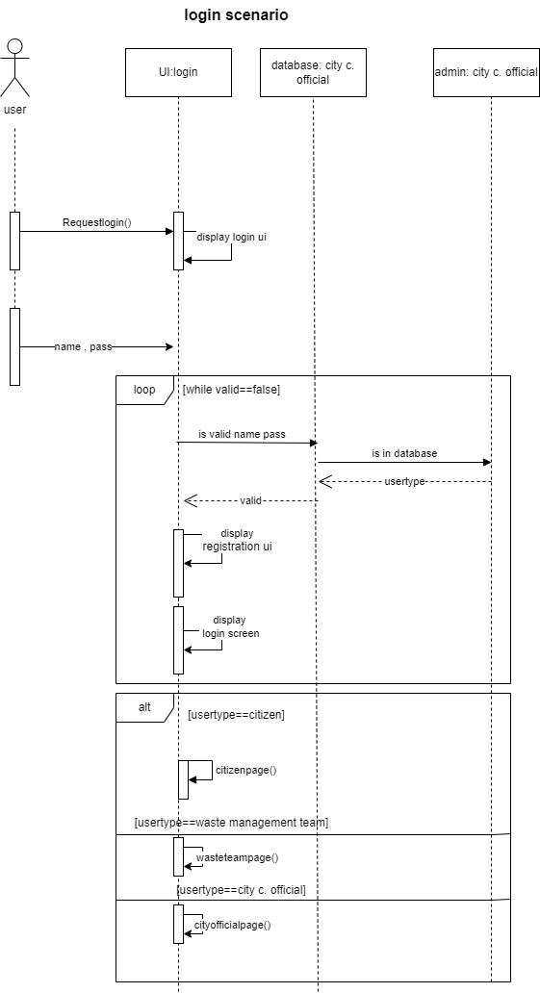

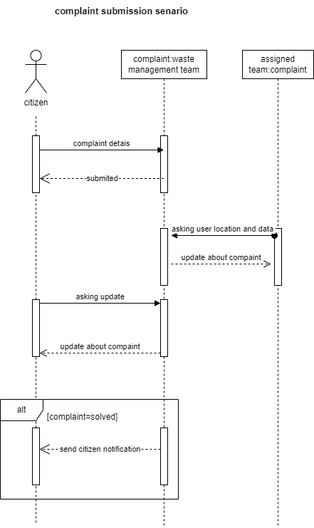

User-interface:



